Media Contact:
Richard Frank
Frank Marketing Associates
949-637-0700
pr@russound.com

RUSSOUND CELEBRATES 2019 BY DELIVERING ON THE PROMISE
OF SUPERLATIVE NEW IN-CEILING & IN-WALL SPEAKERS
NOW SHIPPING

The New IC-Series Has Been Developed From The Ground-Up.
These Architectural Speakers are Tuned for Music and Built to Last and
Include SwiftLock™ - One-Hand, Tool-Less Installation Design

Newmarket, NH - January 1, 2019 - In the world of custom installed entertainment products in homes and businesses, one of the staples of that profession is in-ceiling and in-wall speakers. Honoring that importance, in 2018 Russound undertook nothing less than a complete re-engineering and voicing of their architectural speaker line-up and introduced them to integrators and installers at the 2018 CEDIA. Built and tuned for maximum musicality as well as incorporating a slick, new, tool-less mounting mechanism, called SwiftLock™, these new speakers have been eagerly anticipated. The new year is now seeing shipments of the new IC-Series go out the door.

Charlie Porritt, Russound CEO, is quite thrilled with this new line of architectural loudspeakers, “All parts of the chain of components in an entertainment system are important, but it is the speakers that can really make the difference. These new IC-Series loudspeakers perform beautifully, are built to last, and the upper two levels of speakers feature a slick, new installation system that saves installers a great deal of time and results in a strong, secure mounting - with one hand! By delivering better music reproduction and by making installations easier and faster, the new IC-Series speakers are the best speaker family with which to build business in 2019.”

The new IC-Series line-up was developed to update all of Russound’s current models as well as adding a new in-wall model. Comprised of the following models, the Russound team also paid close attention to feedback from the marketplace and designed the new family so there are logical steps between models with a “good”, “better”, “best” approach.

Within the IC-Series, the new 10-Series speakers are ideal for background music and offers consumers an excellent value in performance at an entry-level price point.

The new 20-Series is perfect for more listening areas in the home or business. With better performance at a slightly higher price, the 20-Series is perfect for rooms where music and audio is frequently listened to: kitchens, master bedrooms, living areas, etc.

The top of the line for the new IC-Series is the 30-Series: designed for what would be considered premium listening. These are the best choice for rooms where audio is of primary interest: like TV-viewing and movie-watching, including home theater areas.

Both the 20- and 30-Series feature the clever mounting mechanism known as SwiftLock™. Designed specifically for Russound by Swarm, this innovative design enables an installer to mount and fasten it in place the speaker with one hand! It locks into place with a positive and resounding “click”, signaling the speaker is securely mounted. This helps installers save time, ensures secure mounts and improves safety.

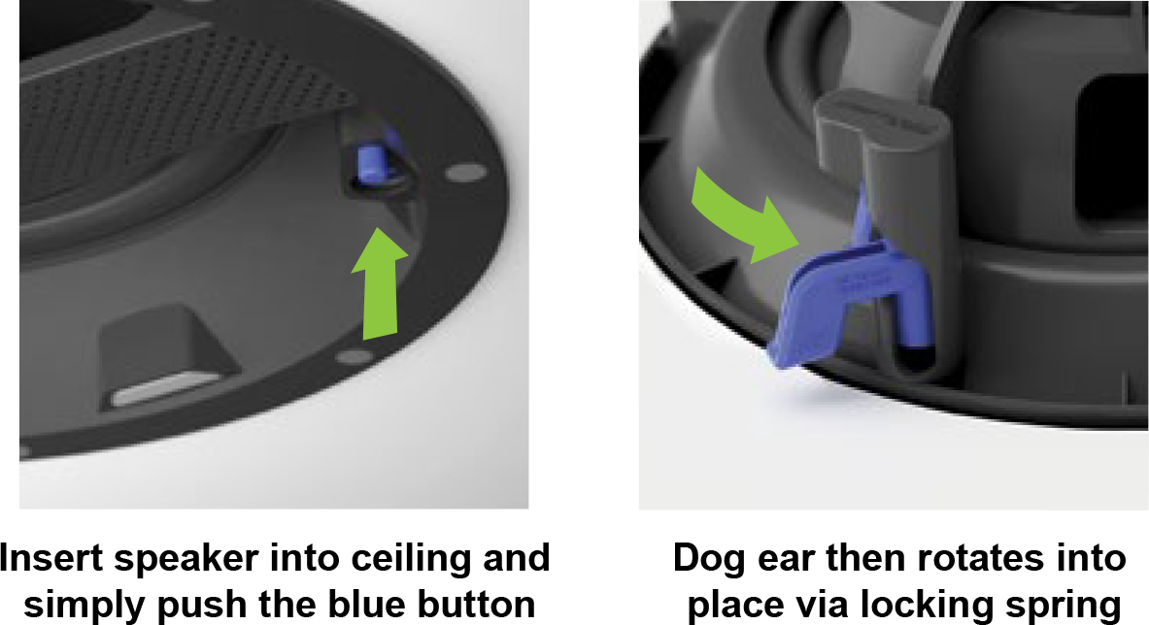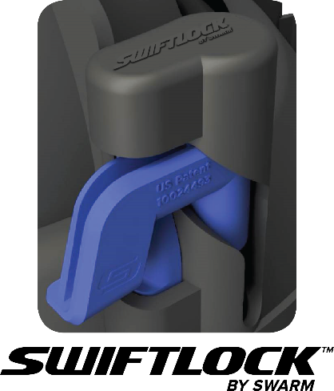

The new IC-Series models, respective MSRP prices and shipping status are:

IC-610 - 2-way 6.5” Vacuum-Formed Poly woofer and 3/4” Pivoting Soft Dome tweeter: MSRP $159 / pair. Shipping Now

IC-610T - Single-Point Stereo, 2-way, 6.5” Vacuum-Formed woofer with dual voice coil and two 1/2” PEI tweeters MSRP: $149 each. Shipping Now

IC-620 - 2-way 6.5” Injection Molded Poly woofer with 1” Silk Dome tweeter, includes SwiftLock™ mounting mechanism MSRP: $299 /pair. Shipping Now

IC-820 - 2-way 8” Injection Molded Poly woofer with 1” Silk Dome tweeter, includes SwiftLock mounting mechanism MSRP: $399 /pair. Shipping in February 2019

IC-630 - 2-way 6.5” Vapor-Deposited Titanium woofer with 1” Titanium tweeter, includes SwiftLock mounting mechanism MSRP: $499 /pair. Shipping Now

IW-620 In-Wall, 2-way 6” Injection Molded Poly woofer with 1” Silk Dome tweeter, includes SwiftLock mounting mechanism. More details coming soon!

MORE INFORMATION
More information on the new IC-Series of loudspeakers is available here:
https://www.russound.com/products/speakers

For any assistance with information, photos, samples, please contact Richard Frank at Frank MarketingAssociates2, 949-637-0700, rfrank.fma2@gmail.com

About Russound
Since 1967, innovation, quality and reliability have been the pillars of the Russound® product tradition. Located in Newmarket, N.H., Russound, a leader in multi-room audio and home entertainment - inside and out, offers the products and expertise customers need to enjoy the finest audio entertainment. With more than 40 years’ experience, Russound continues to cater to installation professionals and their customers by pairing powerful systems using the latest technologies with easy-to-use control systems to give customers high-performance home entertainment at their fingertips.
For more information, visit the company’s Web site at www.russound.com.
###

